ITEM NO. 14

OPERATIONS & MAINTENANCE COMMITTEE AGENDA

Monday, April 17, 2023

4:00 P.M.

East Bay Dischargers Authority
2651 Grant Avenue, San Lorenzo, CA 94580

Committee Members: Johnson (Chair); Azevedo

OM1. Call to Order

OM2. Roll Call

OM3. Public Forum

OM4. EBDA Permit Compliance
(The Committee will be updated on EBDA’s NPDES compliance.)

OM5. Status Report
(The Committee will be updated on EBDA’s O&M activities.)

OM6. Adjournment

Any member of the public may address the Commission at the commencement of the meeting on any matter within the jurisdiction of the Commission. This should not relate to any item on the agenda. It is the policy of the Authority that each person addressing the Commission limit their presentation to three minutes. Non-English speakers using a translator will have a time limit of six minutes. Any member of the public desiring to provide comments to the Commission on an agenda item should do so at the time the item is considered. It is the policy of the Authority that oral comments be limited to three minutes per individual or ten minutes for an organization. Speaker's cards will be available in the Boardroom and are to be completed prior to speaking.

In compliance with the Americans with Disabilities Act of 1990, if you need special assistance to participate in an Authority meeting, or you need a copy of the agenda, or the agenda packet, in an appropriate alternative format, contact Juanita Villasenor at juanita@ebda.org or (510) 278-5910. Notification of at least 48 hours prior to the meeting or time when services are needed will assist the Authority staff in assuring that reasonable arrangements can be made to provide accessibility to the meeting or service.

In compliance with SB 343, related writings of open session items are available for public inspection at East Bay Dischargers Authority, 2651 Grant Avenue, San Lorenzo, CA 94580. For your convenience, agenda items are posted on the East Bay Dischargers Authority website located at http://www.ebda.org.

Next Scheduled Operations and Maintenance Committee:
Monday, May 15, 2023, at 4:00 p.m.

Item No. OM4 EBDA Permit Compliance

Recommendation
For the Committee’s information only; no action is required.

Discussion
There were no NPDES permit violations in January, and preliminary data from February are also free of permit exceedances. Member Agency CBOD and TSS performance are shown below. A table with bacterial indicators is also included.

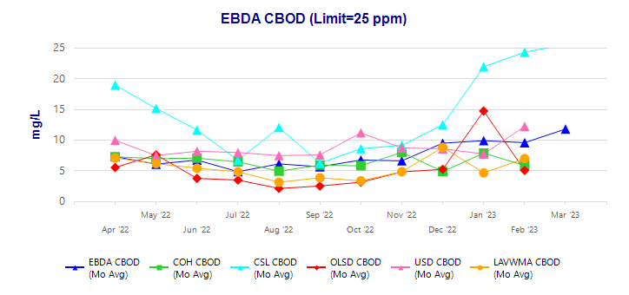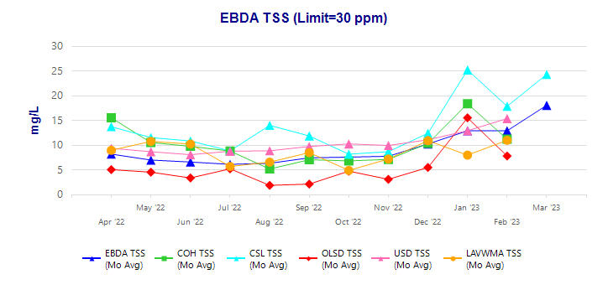

EBDA Bacterial Indicators

 |  | FECAL |  | ENTERO
Date |  | MPN/ 100mL |  | MPN/ 100mL
Limit (90th Percentile) |  | 1100 |  | 1100
Limit (Geomean) |  | 500 |  | 280
April 2022 Geomean |  | 2 |  | 7
May 2022 Geomean |  | 5 |  | 48
June 2022 Geomean |  | 5 |  | 57
July 2022 Geomean |  | 20 |  | 6
August 2022 Geomean |  | 15 |  | 34
September 2022 Geomean |  | 43 |  | 28
October 2022 Geomean |  | 12 |  | 4
November 2022 Geomean |  | 6 |  | 6
December 2022 Geomean |  | 21 |  | 9
January 2023 Geomean |  | 12 |  | 14
2/1/2023 |  | NA |  | 2
2/6/2023 |  | 4 |  | 2
2/7/2023 |  | 2 |  | 6
2/8/2023 |  | NA |  | 2
2/13/2023 |  | 7 | < | 2
2/14/2023 |  | 2 |  | 2
2/20/2023 | < | 2 |  | 6
2/21/2023 |  | 4 |  | 2
2/27/2023 |  | 7 | < | 2
2/28/2023 |  | 5 | < | 2
February 2023 Geomean |  | 4 |  | 2
3/1/2023 |  | NA |  | 6
3/6/2023 |  | 4 |  | 2
3/7/2023 | < | 2 | < | 2
3/8/2023 |  | NA |  | 2
3/13/2023 |  | 2 |  | 2
3/14/2023 |  | 8 | < | 2
3/20/2023 |  | 2 |  | 4
3/21/2023 | < | 2 |  | 2
3/27/2023 |  | 4 | < | 2
3/28/2023 |  | 8 | < | 2
March 2023 Geomean |  | 3 |  | 2

Item No. OM5 Status Report

Union Effluent Pump Station (UEPS)

Effluent Pump No. 6 Variable Frequency Drive (VFD)
On December 29, 2022, the VFD for Effluent Pump No. 6 failed. On March 16, 2023, Rockwell Automation’s Field Service Engineer determined that the inverter section of the VFD was blown and needed to be replaced. EBDA staff obtained quotes for repair/replacement of the inverter and forwarded them to USD. Under the 2020 JPA, USD is responsible for capital at the station, utilizing EBDA’s annual payments. The cause of the failure was determined to be humidity. USD staff had a roofing contractor complete some spot repairs of the roof above the VFD, and an air vent above the VFD was redirected to eliminate the possibility of moisture entering the VFD enclosure.

Hayward Effluent Pump Station (HEPS)

Effluent Pump Replacement Project
On March 6, 2023, Pump Repair Service Company, Inc. (PRS) sent EBDA the Cascade Pump Company submittals for the new HEPS pumps. On March 31, 2023, EBDA responded to the submittal from PRS with input from Currie Engineers (EBDA’s project manager), Beecher Engineering (EBDA’s electrical engineer), and the City of Hayward engineer. The lead time for the new pumps is 28 weeks after submittal approval.

Oro Loma Effluent Pump Station (OLEPS)

Emergency Outfall Upgrade
Carollo Engineers (Carollo) completed an evaluation of the OLEPS emergency outfall to determine the outfall’s maximum capacity and whether modifications to the outfall weir would increase system detention time and delay or prevent an unanticipated bypass in the event of a catastrophic failure at OLEPS. Carollo recommended that the existing lumber weir be replaced with a permanent weir at an increased elevation. Carollo completed the drawing and specifications for construction of the new elevated weir. Bids for the project came in much higher than expected. EBDA staff discussed this project with Jimmy Dang, OLSD’s new General Manager, and he had some value engineering suggestions that should reduce the cost of the project. Staff will review the new project approach with the MAC, and funds will be added to the RRF project list for FY 2023/2024 to complete the project.

Main Electrical Switchboard Upgrade
On March 13, 2023, a thermographic survey of the OLEPS Main Electrical Switchboard was completed. Both OLEPS Electric Pumps were operated at 100% speed for one hour prior to the start of the thermographic survey. The Infrared Thermographic Report stated the following:

“No potential problems were identified in the equipment that was inspected.”

Below is an example of the images included in the report. The results of the thermographic survey were intended to identify any hot spots and verify that the new breaker installation was completed properly. The highest temperature recorded in the thermographic survey was well below the temperature of concern, and no hot spots were identified. The project will be complete once Schneider Electric installs new blanks or spacers to cover the space between the new breakers and the front panels.

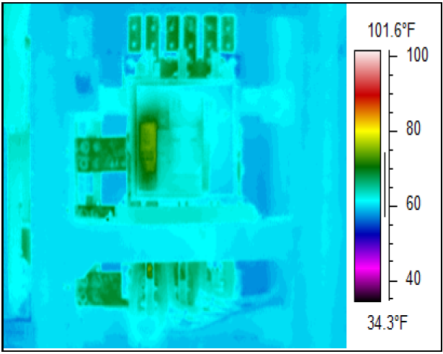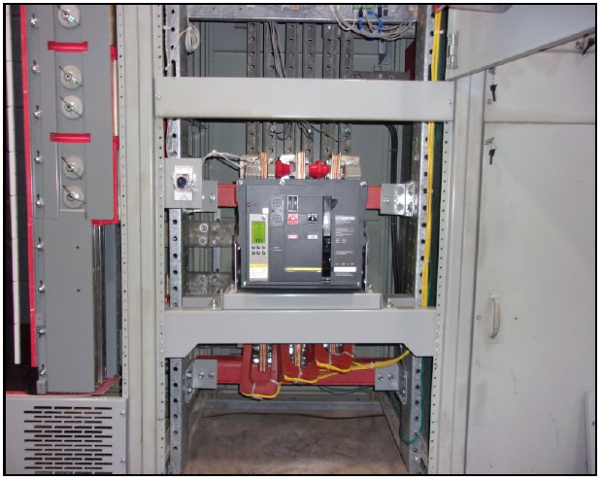

Skywest Pump Station

Recycled Water Production
During the month of March 2023, the Skywest Recycled Water System did not produce any recycled water.

Marina Dechlorination Facility (MDF)

No change; all equipment is operational.

Force Main

No change; all equipment is operational.

Operations Center

No change; all equipment is operational.

Miscellaneous Items

Underground Service Alerts
EBDA received nine (9) Underground Service Alert (USA) tickets during the month of March 2023. Five required an Electronic Positive Response (EPR) and calls/emails to the excavators, and three required field verification.

Wet Weather
Total rainfall for the month of March 2023 (in inches) was as follows:
Oakland | Hayward | Livermore
7.58 | 5.70 | 7.95

Significant daily rainfall for the month of March 2023 (in inches) was as follows:
Date | Oakland | Hayward | Livermore
3/09/2023 | 1.49 | 0.88 | 1.14
3/10/2023 | 0.75 | 0.71 | 1.00
3/12/2023 | 0.35 | 0.77 | 1.02
3/21/2023 | 1.08 | 1.07 | 1.30
Note that multiple sources were aggregated as input for rainfall data.

In March 2023, there were three larger and several smaller but still significant rain events in the EBDA service area. The OLEPS diesel pumps, which operate when the capacity of the two electric pumps is exceeded, were required to operate for 85 hours.

Average daily flow at MDF was as follows:
Date | MDF Average Daily Flow - MGD
October 2022 Monthly Average | 56.6
November 2022 Monthly Average | 63.6
December 2022 Monthly Average | 75.8
January 2023 Monthly Average | 110.4
February 2023 Monthly Average | 78.4
March 2023 Monthly Average | 103.6
3/10/2023 | 152.9
3/12/2023 | 130.1
3/22/2023 | 137.3

Capacity Exceedance Events
Using the methodology in the Amended and Restated Joint Powers Agreement ($0.005/gallon of exceeded flow, based on a 3-hour average), EBDA has calculated the fees owed by EBDA Member Agencies for temporary capacity exceedances during the March storms as follows:

OLSD/CVSan
Date | Duration | Gallons | Capacity Exceedance Fee
3/10/2023 | 14.5 Hours | 10,400,000 | $52,000
3/22/2023 | 15 Hours | 6,600,000 | $33,000
March Total | 29.5 Hours | 17,000,000 | $85,000

EBDA Vehicle
On September 16, 2022, a Purchase Order was submitted to National Auto Fleet Group for EBDA’s new F-150 Truck. On September 26, 2022, staff traded in EBDA’s 2008 Ford Ranger for $9,100. Due to the high trade-in value, it was necessary to trade-in the truck as soon as possible before the trade-in value was reduced. The new F-150 is on order, and EBDA is waiting for an estimated delivery date from Ford.

Special Projects

Roof Replacement Projects
Work restarted on the OLEPS roof and began on the Administration Building roof on April 5th and April 10th, respectively. The old Administration Building roof was removed, and several layers of the new roof are currently being installed. Installation of these layers will make the roof water tight. Before additional layers of the new roof can be installed, a waiting period of several weeks is necessary. The MDF SBS Building roof and the OLEPS roof will be completed shortly, assuming dry weather continues.

Cargill Brine Project
Staff is working with Cargill and our CEQA consultant, Ascent Environmental, on responding to comments received on the Draft Environmental Impact Report (EIR) for the Cargill Mixed Sea Salts Processing and Brine Discharge Project. The formal Response to Comments document will be posted on EBDA’s website when complete, along with a Final EIR. Staff is targeting completion of the EIR by May 2023. At that time, the Commission will be asked to consider certification.

Staff is also negotiating a Project Development and Operating Agreement with Cargill, which would be brought to the Commission for consideration in the coming months. A draft agreement was transmitted to Cargill in late February, following MAC review. A draft technical addendum has also been developed that outlines water quality limitations and monitoring requirements to ensure EBDA’s continued compliance with our NPDES permit once brine discharge commences. The addendum will also include a corrosion monitoring plan, with triggers for action if accelerating corrosion is observed.

Advanced Quantitative Precipitation Information (AQPI) Project
The regional AQPI project continues to move forward with a goal of improving prediction of rainfall events in the Bay Area. Following a series of delays, the East Bay radar was installed at Rocky Ridge on the week of December 6, 2022. EBDA members can access regional data through AQPI’s data portal. Staff met with AQPI’s new Program Manager from the Center for Western Weather and Water Extremes (CW3E) at Scripps Institution of Oceanography, UC San Diego, in February to discuss our data needs going forward and plans for the future user interface. An updated website and data management tools will be in place next year.

